STUDENT NAME

INSTRUCTOR’S NAME

COURSE NUMBER

COURSE TITLE

INVESTMENT PLANNING MODEL

18/5/2021

INTRODUCTION
My company, XYZ Investment Company seeks to invest in common stocks. I have been tasked with developing an investment planning model to model how much money the company will make by investing in the stocks. I will be working with a few assumptions like: sales for the current year are $1000000, sales are expected to increase by 2% annually, the current investment in common stocks is $250000 and annual investment into the common stocks is 1% of net sales. Dividends are also estimated to be 8% per year. Using the information above I will create a five year model and attempt to find out if the investment into the common stocks is worth it. I will also use the model to find out how much the company must invest in order to get a certain amount after the five years.

CHAPTER 1
After 5 years and with the initial assumptions, the investments into common stocks would be worth $303,081.21.
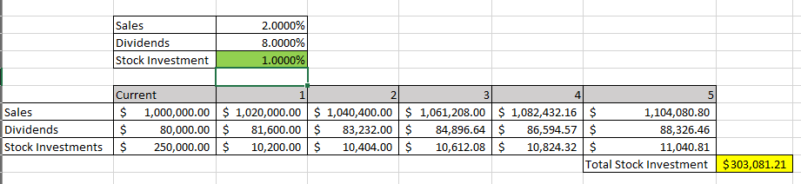
Formulas used in formulation of the model are shown below:
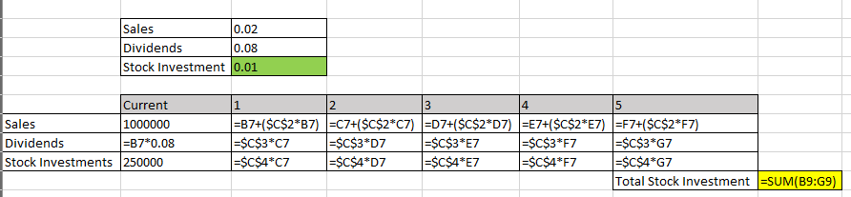
To get $500000 after the 5 years, we need to adjust the rate of investment since the current rate falls well below the $500000 mark. Applying Excel solver on the target Total investment cell while changing the stock investment field yields an investment of 4.7098% to get $500000 after 5 years.
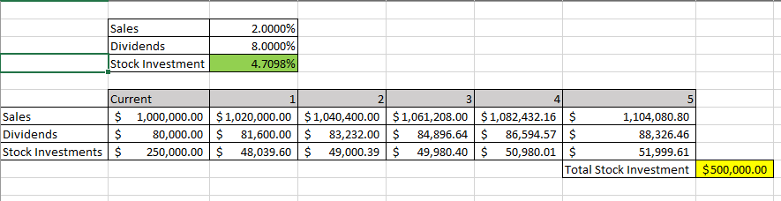
After much deliberation, I decide to change the model t cater for the dynamic real-world environment, especially in the stock market and economy. I incorporate the following changes to the model: The net sales growth ranges from 1% to 6% annually and the portfolio growth rate is a random value generated with an average of 8% and standard deviation of 5%. The model’s formulas are now as shown below:
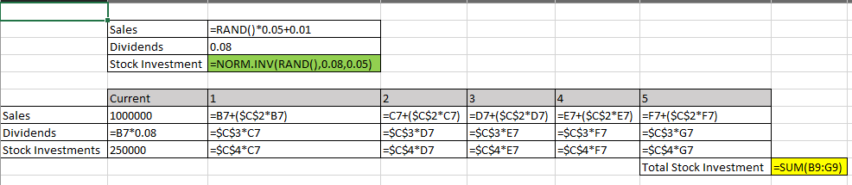
After running the simulation once, the investments in common stock after 5 years is $672391.04.
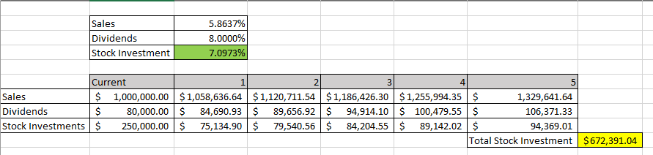
To get $500000 investment amount on common stocks, the company will have to invest 4.2007% of its annual net sales in the common stocks.
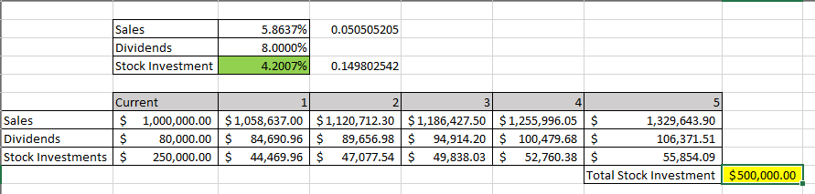
The model I have created above has a wide range of uses in addition to showing the company on how best to invest in the stocks. Individuals can use the same model to tell them how best to invest in personal assets like mortgages. Companies may also use the same to plan for future growth and expansion projects and help them make informed decisions on the same. The model can also show long term viability of an investment, whether the investment is worth it in the long run.

CONCLUSION
The project above covers financial modelling and simulation with Excel. It further goes to show the power of tools provided by excel and how when combined they come up with something spectacular. From the project I was able to learn on how create and simulate financial environments that simulate the real world financial environment, using Excel and its tools. With Excel, the modelling seems to be much easier and faster, as compared to using other modelling tools available.

REFERENCES
Adam. (2018, October 3). How and Why of Running a Simulation in Excel - All You Need to Know. SpreadsheetWeb. https://www.spreadsheetweb.com/simulation-in-excel/.
Kuo, M., Jana, Adhish, Hyein, Sara, Kumar, D., Jody, & Brandon. (2013, September 16). Matthew Kuo. MBA Excel. http://www.mbaexcel.com/excel/how-to-build-an-excel-model-step-by-step/.
Rawhy, Vivas, J., & Yadav, C. (2010, April 21). How to Generate random numbers (with decimals) in Excel. WonderHowTo. https://ms-office.wonderhowto.com/how-to/generate-random-numbers-with-decimals-excel-338595/#:~:text=If%20you%20want%20to%20use,rand()*10%2B100%22.

